;First go to object manager and then in that add new custom object
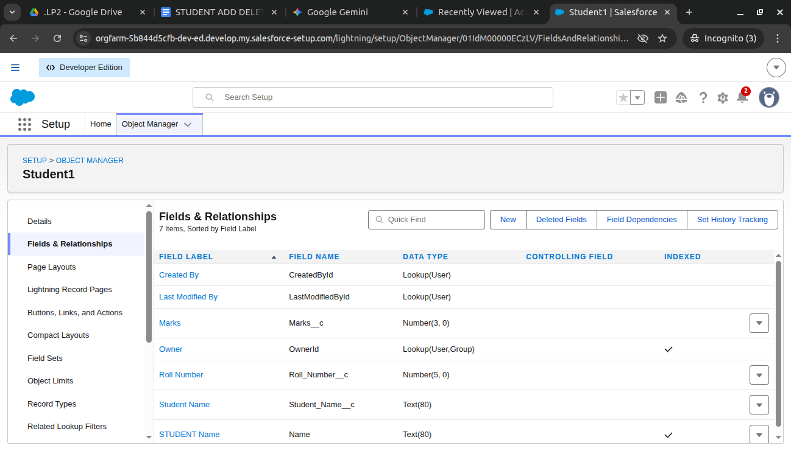

Now add fields and relationship like student name, mark, roll number

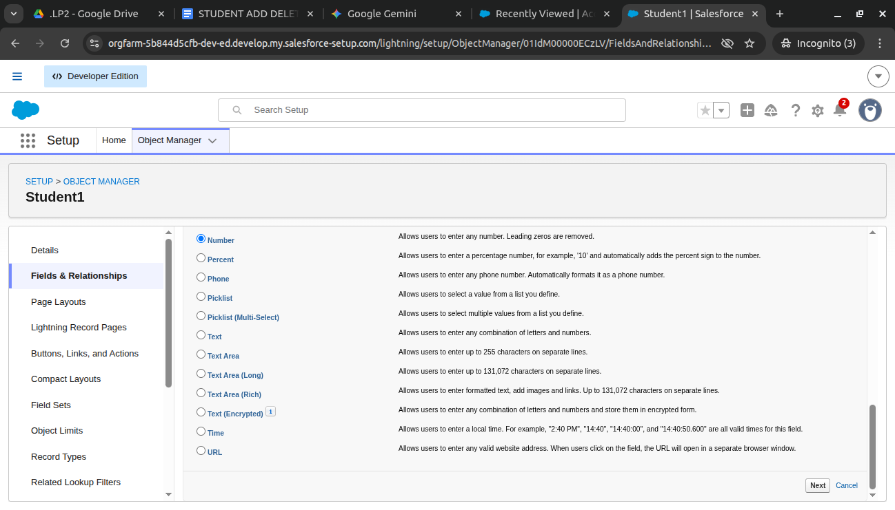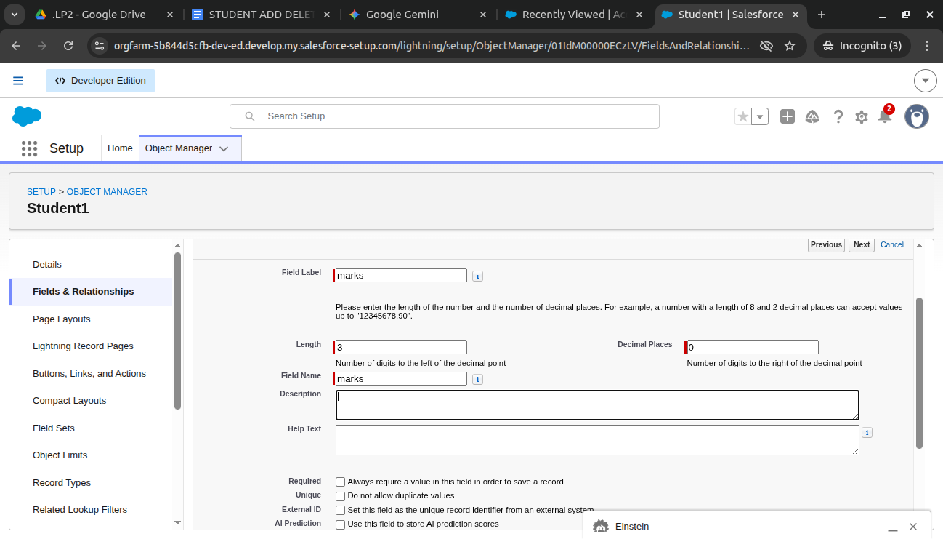

Create the new apex class named StudentController.apex

public class StudentController {
// The Visualforce page looks for this 'student' variable
public Student1__c student {get;set;}
public List<Student1__c> studentList {get;set;}

public StudentController() {
student = new Student1__c();
refreshList();
}

public void refreshList() {
// Querying the Student1__c object
studentList = [SELECT Id, Student_Name__c, Roll_Number__c, Marks__c FROM Student1__c];
}

public void addStudent() {
insert student;
student = new Student1__c(); // Clear form
refreshList();
}

public void deleteStudent() {
if(student.Id != null) {
delete [SELECT Id FROM Student1__c WHERE Id = :student.Id];
refreshList();
}
}
}

Then ctrl+E

// Create instance
StudentController sc = new StudentController();

// Assign values to the student object
sc.student1.Student_Name__c = 'John Doe';
sc.student1.Roll_Number__c = 101;
sc.student1.Marks__c = 85;

// Call the add method
sc.addStudent();

// Verify in logs
System.debug('Current Students: ' + sc.studentList);

Now execute and go to logs and open you will see
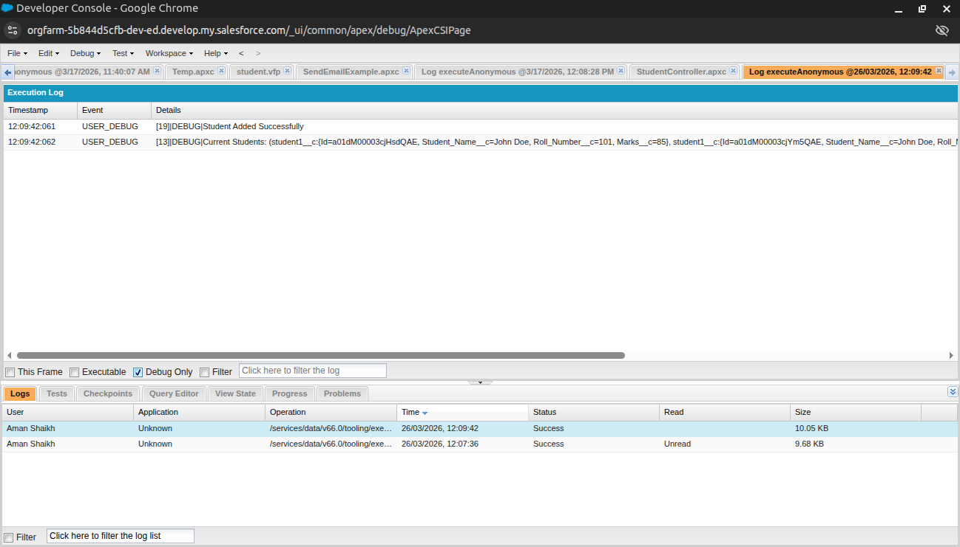

Now using visual force

<apex:page controller="StudentController">
<apex:sectionHeader title="Student Management" subtitle="Assignment 1"/>
<apex:form id="theForm">
<apex:pageBlock title="Add New Student">
<apex:pageBlockSection columns="1">
<apex:inputField value="{!student.Student_Name__c}"/>
<apex:inputField value="{!student.Roll_Number__c}"/>
<apex:inputField value="{!student.Marks__c}"/>
</apex:pageBlockSection>
<apex:pageBlockButtons location="bottom">
<apex:commandButton value="Save Record" action="{!addStudent}" reRender="theForm"/>
</apex:pageBlockButtons>
</apex:pageBlock>

<apex:pageBlock title="Student List">
<apex:pageBlockTable value="{!studentList}" var="s">
<apex:column value="{!s.Student_Name__c}"/>
<apex:column value="{!s.Roll_Number__c}"/>
<apex:column value="{!s.Marks__c}"/>
<apex:column headerValue="Action">
<apex:commandLink value="Delete" action="{!deleteStudent}" reRender="theForm" style="color:red">
<apex:param name="studentId" value="{!s.Id}" assignTo="{!student.Id}"/>
</apex:commandLink>
</apex:column>
</apex:pageBlockTable>
</apex:pageBlock>
</apex:form>
</apex:page>

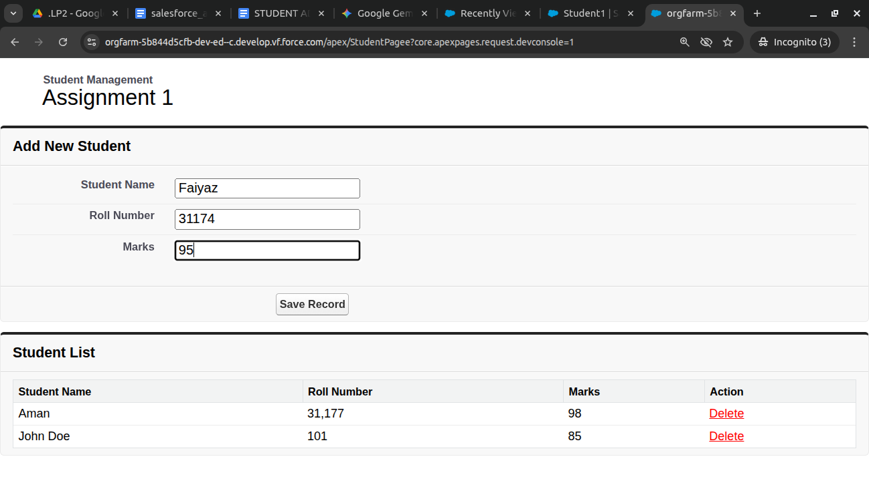

Now next assignment using lightening

Step 1: Create a Custom Tab
- Go to the main Salesforce Setup (the gear icon).
- In the Quick Find box on the left, type Tabs.
- Click on Tabs under the User Interface section.
- In the Custom Object Tabs section, click New.
- Object: Select Student1 (or whatever you named your object).
- Tab Style: Pick any icon you like (e.g., Apple, Books, or People).
- Click Next, then Next again (keep default visibility), and click Save.

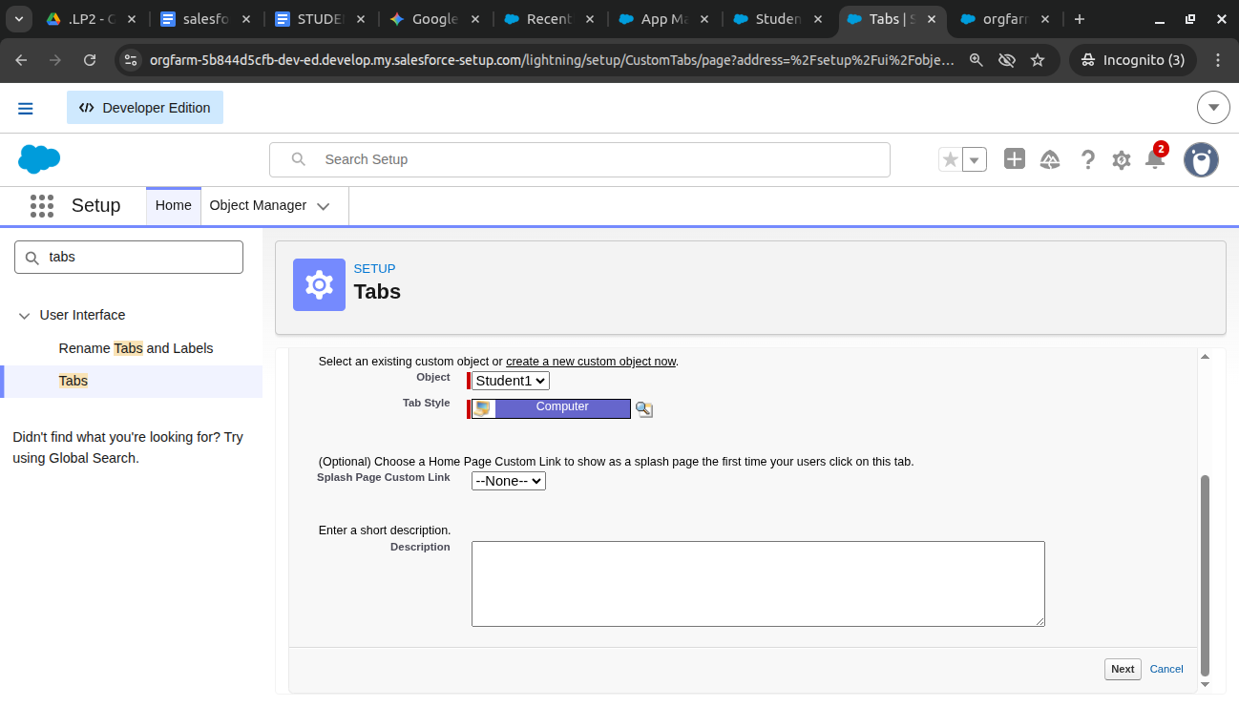

In app management new app

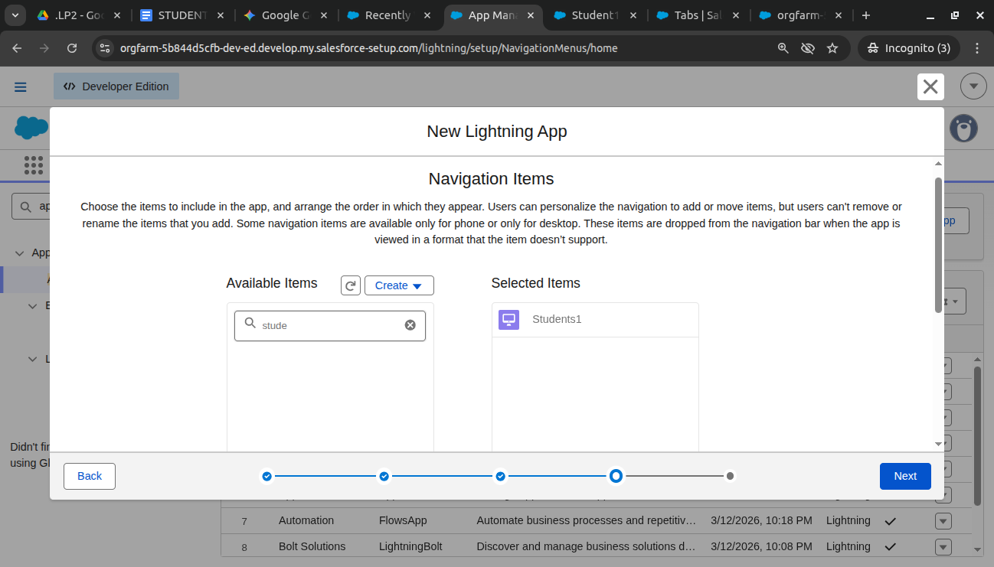

In student1 object go to validation rule 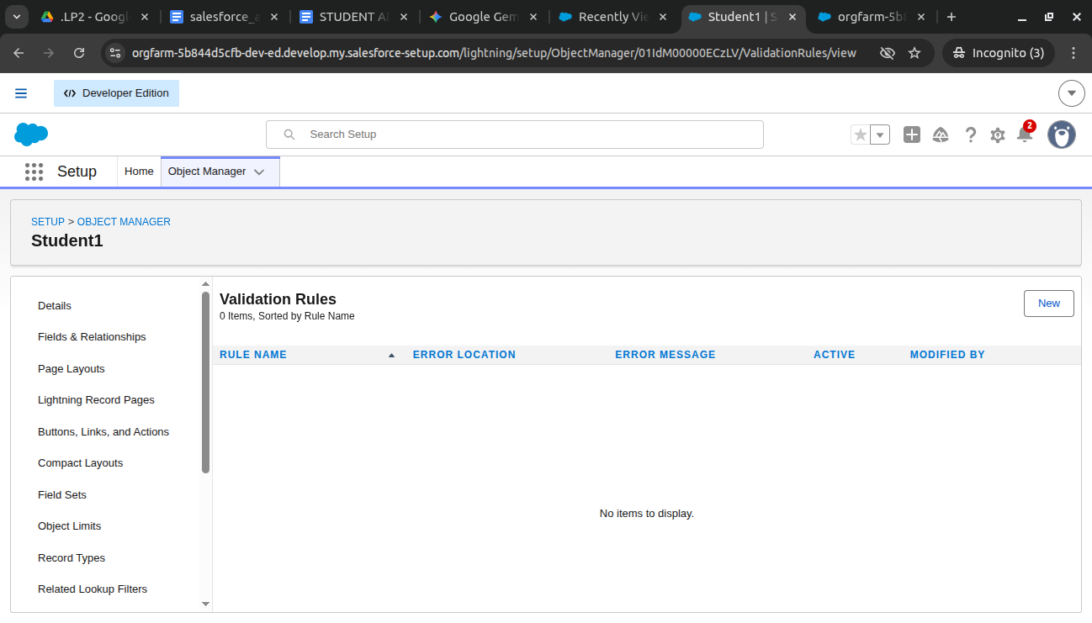

Add avliidatio rules ike marks should have range of 0 to 100
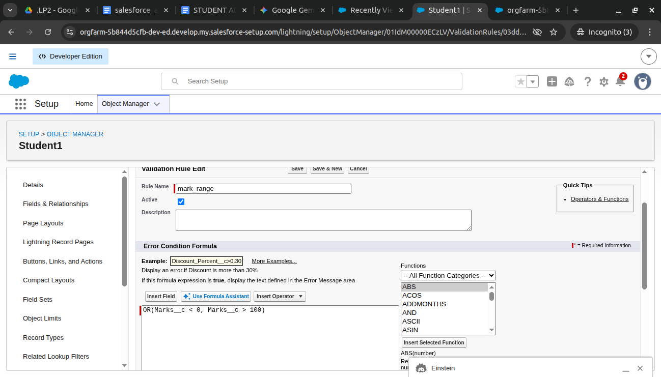
Add error message too
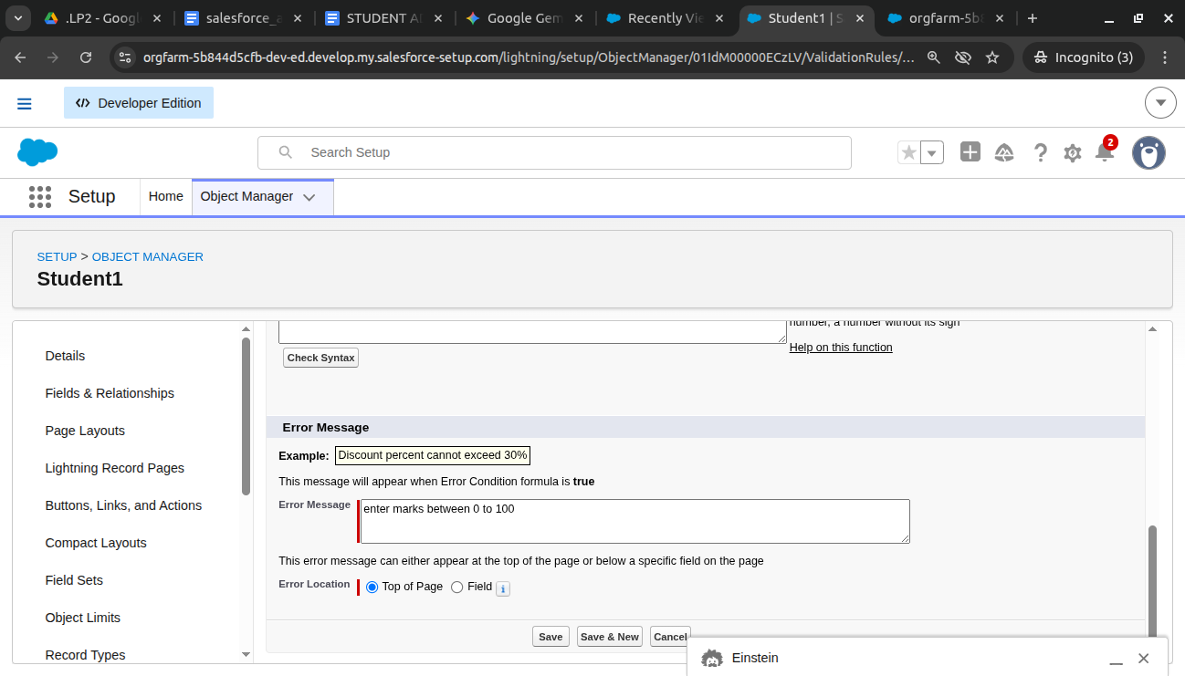

Then see in result for marks (0-100)
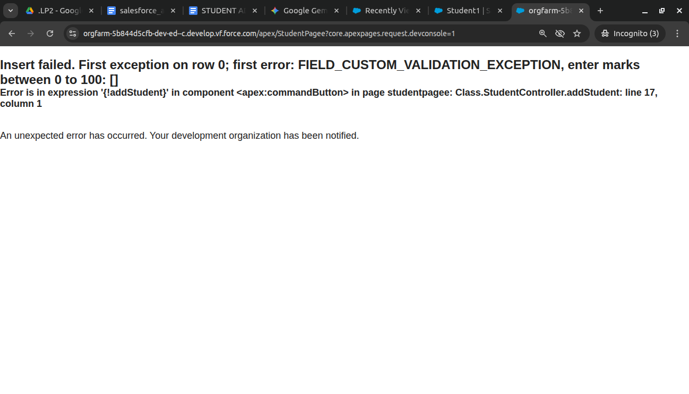

For incorrect roll number => 311011

Step 4: Test in the Lightning App
- Click the App Launcher (the 9-dot grid icon in the top left corner of Salesforce).
- Search for and click Student Management System.
- Click the Students tab.
- Click New

